

# Rossmoyne Senior High School

### Semester Two Examination, 2016

### Question/Answer Booklet

# MATHEMATICS

**SOLUTIONS**

**SPECIALIST**

**UNITS 3 AND 4**

## Section Two:

## Calculator-assumed

|  |  |  |  |  |  |  |  |  |
| --- | --- | --- | --- | --- | --- | --- | --- | --- |
| Student Number: In figures |  |  |  |  |  |  |  |  |

In words

Your name

## Time allowed for this section

Reading time before commencing work: ten minutes

Working time for section: one hundred minutes

## Materials required/recommended for this section

***To be provided by the supervisor***

This Question/Answer Booklet

Formula Sheet (retained from Section One)

***To be provided by the candidate***

Standard items: pens (blue/black preferred), pencils (including coloured), sharpener, correction fluid/tape, eraser, ruler, highlighters

Special items: drawing instruments, templates, notes on two unfolded sheets of A4 paper, and up to three calculators approved for use in the WACE examinations

## Important note to candidates

No other items may be taken into the examination room. It is **your** responsibility to ensure that you do not have any unauthorised notes or other items of a non-personal nature in the examination room. If you have any unauthorised material with you, hand it to the supervisor **before** reading any further.

## Structure of this paper

|  |  |  |  |  |  |
| --- | --- | --- | --- | --- | --- |
| Section | Number of questions available | Number of questions to be answered | Working  time (minutes) | Marks available | Percentage of exam |
| Section One:  Calculator-free | 8 | 8 | 50 | 52 | 35 |
| Section Two:  Calculator-assumed | 12 | 12 | 100 | 97 | 65 |
|  | | | **Total** | 149 | 100 |

## Instructions to candidates

1. The rules for the conduct of examinations are detailed in the school handbook. Sitting this examination implies that you agree to abide by these rules.

2. Write your answers in this Question/Answer Booklet.

3. You must be careful to confine your response to the specific question asked and to follow any instructions that are specified to a particular question.

4. Spare pages are included at the end of this booklet. They can be used for planning your responses and/or as additional space if required to continue an answer.

* Planning: If you use the spare pages for planning, indicate this clearly at the top of the page.
* Continuing an answer: If you need to use the space to continue an answer, indicate in the original answer space where the answer is continued, i.e. give the page number. Fill in the number of the question that you are continuing to answer at the top of the page.

5. **Show** **all your working clearly**. Your working should be in sufficient detail to allow your answers to be checked readily and for marks to be awarded for reasoning. Incorrect answers given without supporting reasoning cannot be allocated any marks. For any question or part question worth more than two marks, valid working or justification is required to receive full marks. If you repeat any question, ensure that you cancel the answer you do not wish to have marked.

6. It is recommended that you **do not use pencil**, except in diagrams.

7. The Formula Sheet is **not** to be handed in with your Question/Booklet.

Section Two: Calculator-assumed 65% (97 Marks)

This section has**twelve (****12)** questions. Answer **all** questions. Write your answers in the spaces provided.

Working time for this section is 100 minutes.

Question 9 (6 marks)

A system of equations is shown below.

$$x+2y+3z=1 \\ y+3z=-1 \\ -y+\left(a^{2}-4\right)z=a+2$$

(a) Determine the unique solution to the system when $a=2$. (2 marks)

|  |
| --- |
| **Solution** |
| $-y=4⇒y=-4$ $3z=-1+4=3⇒z=1$ $x-8+3=1⇒x=6$ $x=6, y=-4, z=1$ |
| **Specific behaviours** |
| ✓ substitutes and solves for y  ✓ solves for z and x |

(b) Determine the value(s) of $a$ so that the system

(i) has an infinite number of solutions. (3 marks)

|  |
| --- |
| **Solution** |
| $\left(a^{2}-4+3\right)z=a+2-1$ $\left(a+1\right)\left(a-1\right)z=a+1$ Require $a=-1$ for an infinite number of solutions |
| **Specific behaviours** |
| ✓ adds row2 and row 3 to eliminate y  ✓ factorises  ✓ states value of a |

(ii) has no solutions. (1 mark)

|  |
| --- |
| **Solution** |
| Require $a=1$ for no solutions |
| **Specific behaviours** |
| ✓ states value of a |

Question 10 (8 marks)

The length of time, $T$ months, that an athlete stays in an elite squad can be modelled by a normal distribution with population mean $μ$ and population variance $σ^{2}=15$.

(a) An independent sample of five values of T is $7.7, 15.2, 3.9, 13.4$ and $11.8$ months.

(i) Calculate the mean of this sample and state the distribution that a large number of such samples is expected to follow. (2 marks)

|  |
| --- |
| **Solution** |
| $\overline{x}=\frac{52}{5}=10.4$ months  Sample means normally distributed with mean $μ$ and variance $σ^{2}=\frac{15}{5}=3$ months |
| **Specific behaviours** |
| ✓ calculates sample mean  ✓ states distribution with mean and variance |

(ii) Use this sample to construct a 90% confidence interval for $μ$, giving the bounds of the interval to two decimal places. (3 marks)

|  |
| --- |
| **Solution** |
| $z=1.645$ for 90% CI $10.4±1.645×\sqrt{3}$   Interval is $7.55<μ<13.25$ months |
| **Specific behaviours** |
| ✓ uses correct z-score  ✓ calculates lower bound, rounding  ✓ calculates upper bound, rounding |

(b) Determine the smallest number of values of T that would be required in a sample for the total width of a 95% confidence interval for $μ$ to be less than 3 months. (3 marks)

|  |
| --- |
| **Solution** |
| $$z=1.96, σ=\sqrt{15} \\ n={\left(\frac{1.96×\sqrt{15}}{1.5}\right)}^{2}=25.61$$ Smallest sample size is $n=26$ |
| **Specific behaviours** |
| ✓ shows z-score, variance and interval half-width used  ✓ calculates n  ✓ rounds n up |

Question 11 (7 marks)

Plane $p_{1}$ has equation $3x+y+z=6$ and line l has equation $r=i+j+2k+t(i-2j-k)$.

(a) Show that the line l lies in the plane $p_{1}$. (3 marks)

|  |
| --- |
| **Solution** |
| $p_{1}$ can be expressed as $r⋅\left[\begin{matrix}3 \\ 1 \\ 1\end{matrix}\right]=6$ and l as $r=\left[\begin{matrix}1+t \\ 1-2t \\ 2-t\end{matrix}\right]$ Then $\left[\begin{matrix}1+t \\ 1-2t \\ 2-t\end{matrix}\right] ⋅\left[\begin{matrix}3 \\ 1 \\ 1\end{matrix}\right]=6$ Which simplifies to $3+3t+1-2t+2-t=6$ and then to $6=6$ Hence line lies in plane. |
| **Specific behaviours** |
| ✓ writes plane in vector form  ✓ substitutes line into plane equation  ✓ simplifies and draws conclusion |

(b) Another plane, $p_{2}$, is perpendicular to plane $p_{1}$, parallel to the line l and contains the point with position vector $i-3j-k$. Determine the equation of plane $p_{2}$, giving your answer in the form $ax+by+cz=d$. (4 marks)

|  |
| --- |
| **Solution** |
| $p_{2}$ must contain vectors $\left[\begin{matrix}3 \\ 1 \\ 1\end{matrix}\right]$ and $\left[\begin{matrix}1 \\ -2 \\ -1\end{matrix}\right]$ $n=\left[\begin{matrix}3 \\ 1 \\ 1\end{matrix}\right]×\left[\begin{matrix}1 \\ -2 \\ -1\end{matrix}\right]=\left[\begin{matrix}1 \\ 4 \\ -7\end{matrix}\right]$ $r⋅n=\left[\begin{matrix}1 \\ 4 \\ -7\end{matrix}\right]⋅\left[\begin{matrix}1 \\ -3 \\ -1\end{matrix}\right]=-4$   Hence equation of $p_{2}$ is $r⋅\left[\begin{matrix}1 \\ 4 \\ -7\end{matrix}\right]=-4⇒x+4y-7z=-4$ |
| **Specific behaviours** |
| ✓ uses two vectors in the plane  ✓ calculates normal using cross product  ✓ obtains vector equation of  ✓ writes plane in required form |

Question 12 (13 marks)

(a) Show that the gradient of the curve $2x^{2}+y^{2}=3xy$ at the point $(1, 2)$ is $2$. (3 marks)

|  |
| --- |
| **Solution** |
| $2(2)x+2yy'=3y+3xy'$ $x=1,y=2⇒4+4y^{'}=6+3y^{'}⇒y^{'}=2$ |
| **Specific behaviours** |
| ✓ correctly differentiates LHS  ✓ correctly differentiates RHS  ✓ substitutes x and y values and simplifies to show gradient |

(b) Another curve passing through the point $\left(-2, 10\right)$ has gradient given by $\frac{dy}{dx}=\frac{2xy}{1+x^{2}}$.

Use a method involving separation of variables and integration to determine the equation of the curve. (4 marks)

|  |
| --- |
| **Solution** |
| $$\int{\frac{1}{y}}dy=\int{\frac{2x}{1+x^{2}}}dx \\ \ln{y}=\ln\left(1+x^{2}\right)+c \\ y=k(1+x^{2}) \\ y=10, x=-2⇒k=2 \\ y=2(1+x^{2})$$ |
| **Specific behaviours** |
| ✓ separates variables  ✓ integrates both sides  ✓ eliminates natural logs  ✓ determines constant and writes solution |

(c) A particle is moving along the curve given by $y=\sqrt[3]{x}$, with one unit on both axes equal to one centimetre. When $x=1$, the y-coordinate of the position of the particle is increasing at the rate of 2 centimetres per second.

(i) Show that the x-coordinate is increasing at 6 centimetres per second at this instant.

(2 marks)

|  |
| --- |
| **Solution** |
| $$\frac{dy}{dx}=\frac{1}{3}x^{-\frac{2}{3}} \\ \frac{dx}{dt}=\frac{dx}{dy}×\frac{dy}{dt}=3{(1)}^{\frac{2}{3}}×2=6 \text{cm/s}$$ |
| **Specific behaviours** |
| ✓ uses chain rule  ✓ shows substitution of x-coordinate and given rate |

(ii) Determine the exact rate at which the distance of the particle from the origin is changing at this instant. (4 marks)

|  |
| --- |
| **Solution** |
| $$D=\sqrt{x^{2}+y^{2}}=\sqrt{x^{2}+x^{\frac{2}{3}}} \\ \frac{dD}{dx}=\frac{3x^{\frac{4}{3}}+1}{3\sqrt[3]{x}\sqrt{x^{2}+x^{\frac{2}{3}}}} \\ x=1⇒\frac{dD}{dx}=\frac{2\sqrt{2}}{3} \\ \frac{dD}{dt}=\frac{dD}{dx}×\frac{dx}{dt}=\frac{2\sqrt{2}}{3}×6=4\sqrt{2} \text{cm/s}$$ |
| **Specific behaviours** |
| ✓ determines expression for distance in terms of one variable  ✓ differentiates expression wrt to variable  ✓ substitutes, using chain rule  ✓ simplifies in exact form |

Question 13 (8 marks)

(a) Sketch the graph of $y=\frac{2x+1}{x+1}$ on the axes below. (2 marks)

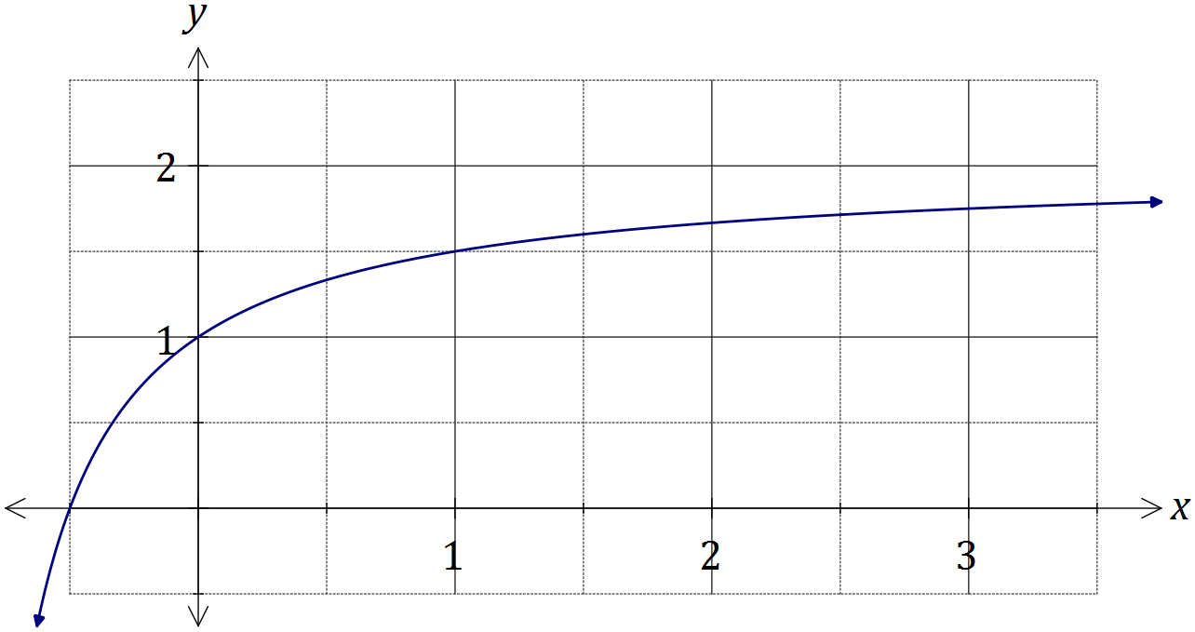

|  |
| --- |
| **Solution** |
| See graph |
| **Specific behaviours** |
| ✓ axes intercepts and (1, 1)  ✓ smooth curve |

Simpson's rule is a formula used for numerical integration, the numerical approximation of definite integrals. When an interval $[a_{0}, a_{n}]$ is divided into an even number, $n$, of smaller intervals of equal width $w$, the bounds of these smaller intervals are denoted $a_{0}, { a}_{1}, a_{2},…, a_{n-1}, { a}_{n}$. Simpson's rule can be expressed as follows:

$$\int_{a_{0}}^{a_{n}}{f(x)}dx=\frac{w}{3}(B+2E+4O)$$

where $B=f(a_{0})+f(a_{n})$, $E$ is the sum of the values of $f\left(a_{k}\right)$ where $k$ is even and $O$ is the sum of the values of $f\left(a_{k}\right)$ where $k$ is odd.

(b) Use Simpson's rule with $n=6$ to evaluate an approximation for $\int_{0}^{3}{\frac{2x+1}{x+1}}dx$, correct to four decimal places. (4 marks)

|  |
| --- |
| **Solution** |
| $a_{0}=1, a_{1}=\frac{4}{3}, a_{2}=\frac{3}{2}, a_{3}=\frac{8}{5}, a_{4}=\frac{5}{3}, a_{5}=\frac{12}{7}, a_{6}=\frac{7}{4}$ $B=\frac{11}{4}, E=\frac{19}{6}, O=\frac{488}{105}$ $\frac{1/2 }{3}\left(\frac{11}{4}+2×\frac{19}{6}+4×\frac{488}{105}\right)=\frac{11623}{2520}≈4.6123$ |
| **Specific behaviours** |
| ✓ calculates ordinates  ✓ calculates B, E and O  ✓ evaluates using rule  ✓ accurate to 4 dp |

(c) Determine the exact value of $\int_{0}^{3}{\frac{2x+1}{x+1}}dx$ and hence calculate the percentage error of the approximation from (b). (2 marks)

|  |
| --- |
| **Solution** |
| $\int_{0}^{3}{\frac{2x+1}{x+1}}dx=6-2\ln{2}$. Hence $\frac{\left(\left(6-2\ln{2}\right)-\frac{11623}{2520}\right)}{6-2\ln{2}}×100≈0.03\%$ error. |
| **Specific behaviours** |
| ✓ calculates exact value  ✓ calculates % error |

Question 14 (7 marks)

(a) The equation of a sphere with centre at $(2, -3, 1)$ is $x^{2}+y^{2}+z^{2}=ax+by+cz-2$.

Determine the values of $a, b, c$ and the radius of the circle. (3 marks)

|  |
| --- |
| **Solution** |
| Expanding ${\left(x-2\right)}^{2}+{\left(y+3\right)}^{2}+{\left(z-1\right)}^{2}=r^{2}$ Gives $x^{2}+y^{2}+z^{2}-4x+6y-2z+14=r^{2}$ Hence $a=4, b=-6, c=2$ and $r^{2}-14=-2⇒r=\sqrt{12}=2\sqrt{3}$ |
| **Specific behaviours** |
| ✓ uses standard circle form and expands  ✓ states values of a, b and c  ✓ determines radius |

(b) Two particles, P and Q, leave their initial positions at the same time and travel with constant velocities shown in the table below.

|  |  |  |
| --- | --- | --- |
| Particle | Initial position | Velocity |
| P | $$10i-5j+5k$$ | $$6i+2j-4k$$ |
| Q | $$28i+22j-31k$$ | $$2i-4j+4k$$ |

Show that the two particles collide, stating the position vector of the point of collision.

(4 marks)

|  |
| --- |
| **Solution** |
| $r_{P}=\left[\begin{matrix}10+6t \\ -5+2t \\ 5-4t\end{matrix}\right]$, $r_{Q}=\left[\begin{matrix}28+2t \\ 22-4t \\ -31+4t\end{matrix}\right]$ Solving $10+6t=28+2t⇒ t=4.5$. $r_{P}(4.5)=\left[\begin{matrix}37 \\ 4 \\ -13\end{matrix}\right]$ , $r_{Q}(4.5)=\left[\begin{matrix}37 \\ 4 \\ -13\end{matrix}\right]$ Hence collide at $37i+4j-13k$ when $t=4.5$ |
| **Specific behaviours** |
| ✓ states vector equations of both paths  ✓ solves for $t$ using one pair of coefficients  ✓ substitutes to show both have same position  ✓ states position vector of point of collision |

Question 15 (8 marks)

(a) Briefly describe a reason that a sample rather than a complete population may be used when carrying out a statistical investigation. (1 mark)

|  |
| --- |
| **Solution** |
| Cheaper, Quicker, Easier, etc. |
| **Specific behaviours** |
| ✓ any legitimate reason |

(b) A researcher used government records to select a random sample of the ages of 114 men who had died recently in a town close to an industrial complex. The mean and standard deviation of the ages in the sample were 73.3 and 8.27 years respectively.

(i) Explain why the sample standard deviation is a reasonable estimate for the population standard deviation in this case. (1 mark)

|  |
| --- |
| **Solution** |
| The sample size is large and well above 30. |
| **Specific behaviours** |
| ✓ states large sample size |

(ii) Calculate a 98% confidence interval for the population mean and explain what the interval shows. (4 marks)

|  |
| --- |
| **Solution** |
| z-score for 98% interval is 2.326 $73.3±2.326×\frac{8.27}{\sqrt{114}}=\left(71.5, 75.1\right)$   We are 98% confident that the true mean lies between 71.5 and 75.1 years. |
| **Specific behaviours** |
| ✓ uses correct z-score  ✓ demonstrates calculation used to calculate interval  ✓ calculates correct interval  ✓ explains interval |

(iii) The national average life-span of men was known to be 75.3 years. State with a reason what conclusion the researcher could draw from the confidence interval calculated in (ii) about the life-span of men in the town. (2 marks)

|  |
| --- |
| **Solution** |
| There is a significant difference in life-span of men in the town from those nationally, as the interval does not contain 75.3. |
| **Specific behaviours** |
| ✓ notes interval does not contain 75.3  ✓ uses 'difference' and 'lifespan' in explanation |

Question 16 (8 marks)

(a) On the Argand diagram below, clearly show the region that satisfies the complex inequalities given by $\left|z+3-4i\right|≤5$ and $\frac{π}{2}≤\arg{z}≤π$. (4 marks)

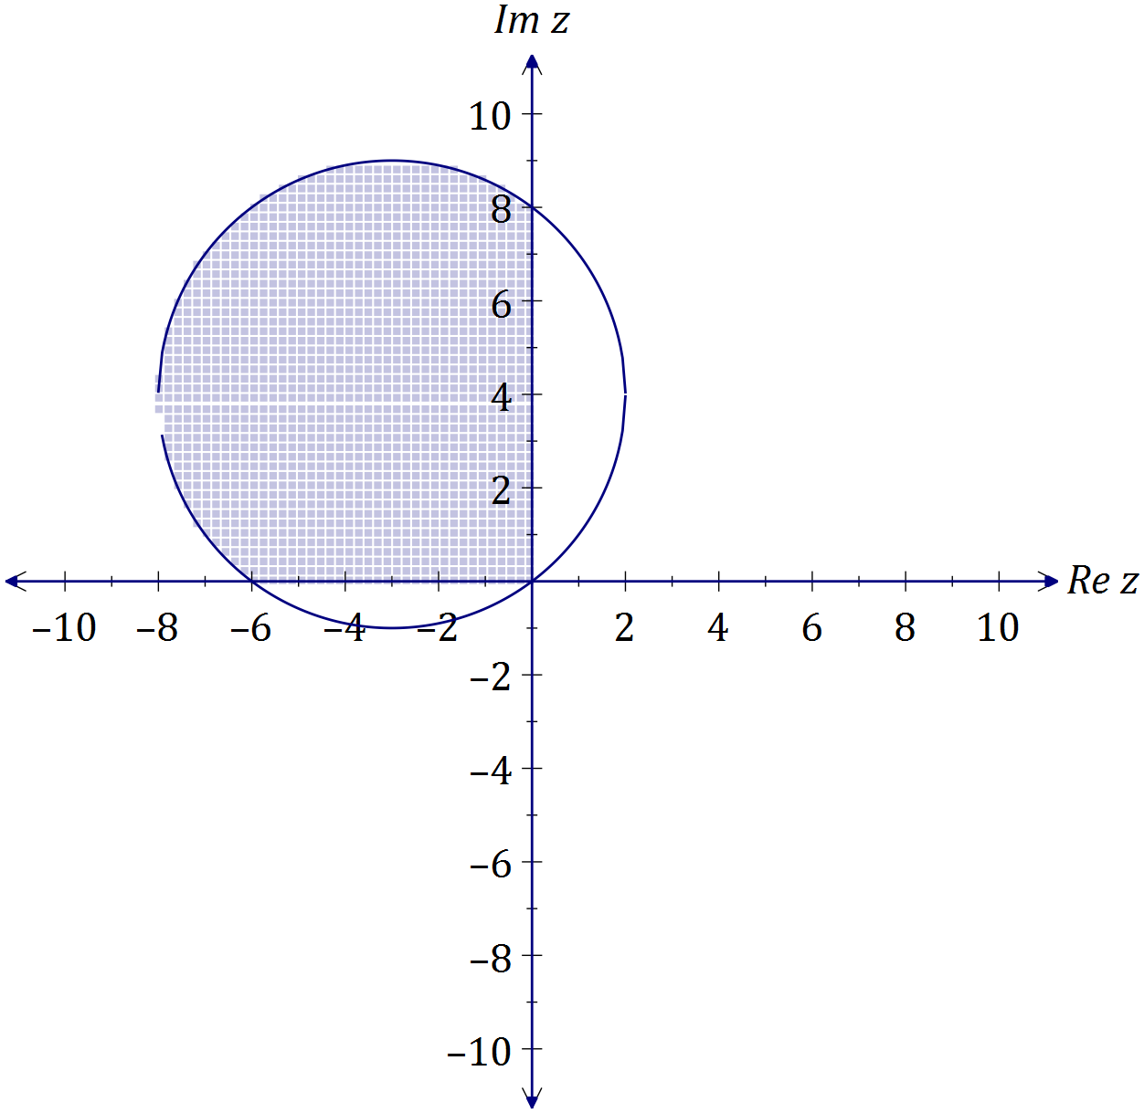

|  |
| --- |
| **Solution** |
| See diagram, |
| **Specific behaviours** |
| ✓ circle with centre (-3,4) and radius 5  ✓ circle intercepts at (0,0), (0,8), (-6,0)  ✓ shades inside circle  ✓ only shades in second quadrant |

(b) Determine all roots of the equation $z^{5}=16\sqrt{3}+16i$, expressing them in the form $r\operatorname{cis}{θ}$, where $r≥0$ and $-π≤θ≤π$. (4 marks)

|  |
| --- |
| **Solution** |
| $z^{5}=32\operatorname{cis}{\frac{π}{6}}$ $z_{1}=2\operatorname{cis}\left(\frac{π}{30}\right)$ $z_{2}=2\operatorname{cis}\left(\frac{13π}{30}\right)$ $z_{3}=2\operatorname{cis}\left(\frac{25π}{30}\right)$ $z_{4}=2\operatorname{cis}\left(\frac{-11π}{30}\right)$ $z_{5}=2\operatorname{cis}\left(\frac{-23π}{30}\right)$ |
| **Specific behaviours** |
| ✓ expresses $z^{5}$ in polar form  ✓ determines first root  ✓ determines other two roots with positive arguments  ✓ determines other two roots with negative arguments |

Question 17 (7 marks)

The graph of $y=f(x)$ is shown below, where $f\left(x\right)={4cos}^{4}{(2x)}$ and A is the smallest root of $f\left(x\right), x>0$.

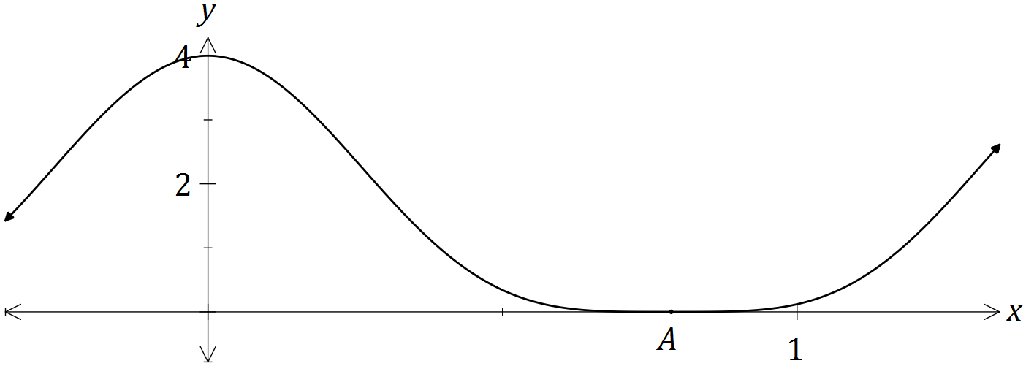

(a) Show that ${4cos}^{4}{(2x)}=\frac{3+4\cos{(4x)}+\cos{(8x)}}{2}$. (3 marks)

|  |
| --- |
| **Solution** |
| $$4\cos^{4}\left(2x\right)={{4(cos}^{2}{(2x))}}^{2} \\ ={4\left(\frac{1+\cos{4x}}{2}\right)}^{2} \\ =1+2\cos{4x}+\cos^{2}{4x} \\ =1+2\cos{4x}+\frac{1+\cos{8x}}{2} \\ =\frac{3+4\cos{(4x)}+\cos{(8x)}}{2}$$ |
| **Specific behaviours** |
| ✓ uses double angle identity  ✓ expands and uses identity again  ✓ simplifies as required |

(b) Hence determine $\int{{4cos}^{4}{(2x)}}dx$. (2 marks)

|  |
| --- |
| **Solution** |
| $$\int{\frac{3+4\cos{(4x)}+\cos{(8x)}}{2}}dx=\frac{3x}{2}+\frac{1}{2}\sin{4x}+\frac{1}{16}\sin{8x}+c$$ |
| **Specific behaviours** |
| ✓ uses result from (a) to integrate  ✓ obtains correct result, including constant |

(c) Determine the exact volume of the solid generated when the region bounded by $=f\left(x\right),$ $y=0$, $x=0$ and $x=A$ is rotated through 360° about the x-axis.

(2 marks)

|  |
| --- |
| **Solution** |
| $\int_{0}^{\frac{π}{4}}{π}{\left(4\cos^{4}\left(2x\right)\right)}^{2}dx=\frac{35π^{2}}{32}$ cubic units |
| **Specific behaviours** |
| ✓ writes integral  ✓ evaluates integral in exact form |

Question 18 (10 marks)

(a) A small object has initial position vector $r\left(0\right)=i+3j-k$ metres and moves with velocity vector given by ms-1, where is the time in seconds.

(i) Show that the acceleration of the object is constant and state the magnitude of the acceleration. (2 marks)

|  |
| --- |
| **Solution** |
| $a\left(t\right)=2i-4j$- hence constant acceleration.  ms-2 |
| **Specific behaviours** |
| ✓ differentiates velocity  ✓ evaluates magnitude |

(ii) Determine the position vector of the object after 2 seconds. (3 marks)

|  |
| --- |
| **Solution** |
| $r\left(t\right)=t^{2}i-2t^{2}j+3tk+const$ $r\left(0\right)=i+3j-k⇒r\left(t\right)=\left(t^{2}+1\right)i+(3-2t^{2})j+(3t-1)k$ $r\left(2\right)=\left(2^{2}+1\right)i+\left(3-2{\left(2\right)}^{2}\right)j+\left(3\left(2\right)-1\right)k=5i-5j+5k$ |
| **Specific behaviours** |
| ✓ integrates velocity  ✓ uses initial condition  ✓ determines position vector |

(b) Another small object has position vector given by $r\left(t\right)=\left(1+2\sec{t}\right)i+\left(3\tan{t}-2\right)j$ m, where $t$ is the time in seconds.

(i) Determine the distance of the object from the origin when $t=\frac{π}{3}$. (2 marks)

|  |
| --- |
| **Solution** |
| Distance is 5.93 m (2 decimal places) |
| **Specific behaviours** |
| ✓ substitutes $\frac{pi}{3}$ and simplifies  ✓ determines magnitude |

(ii) Derive the Cartesian equation of the path of this object. (3 marks)

|  |
| --- |
| **Solution** |
| $$x=1+2\sec{t} , y=3\tan{t}-2$$ $$\sec^{2}{t}-\tan^{2}{t}=1⇒{\left(\frac{x-1}{2}\right)}^{2}-{\left(\frac{y+2}{3}\right)}^{2}=1$$ |
| **Specific behaviours** |
| ✓ equates x and y components  ✓ uses trig identity  ✓ rearranges and substitutes correctly |

Question 19 (7 marks)

(a) A particle undergoing simple harmonic motion with a period of 5 seconds is observed to move in a straight line, oscillating 3.6 m either side of a central position. Determine the speed of the particle when it is 3 m from the central position. (3 marks)

|  |
| --- |
| **Solution** |
|  |
| **Specific behaviours** |
| ✓ determines  ✓ substitutes into velocity equation  ✓ evaluates speed |

(b) Another particle moving in a straight line experiences an acceleration of ms-2, where is the position of the particle at time $t$ seconds.

Given that when $x=1$, the particle had a velocity of 2 ms-1, determine the velocity of the particle when $x=2$. (4 marks)

|  |
| --- |
| **Solution** |
| $$\frac{1}{2}v^{2}=\int{x+2.5}dx \\ v^{2}=2\left(\frac{x^{2}}{2}+2.5x\right)+c \\ x=1, v=2⇒c=-2 \\ x=2⇒v^{2}=2\left(\frac{2^{2}}{2}+2.5(2)\right)-2⇒v=±2\sqrt{3}$$ |
| **Specific behaviours** |
| ✓ uses appropriate form of acceleration  ✓ integrates  ✓ evaluates constant  ✓ states all possible values of v |

Question 20 (8 marks)

The complex numbers $w$ and $z$ are given by $-\frac{1}{2}-\frac{\sqrt{3}}{2}i$ and $r(\cos{θ}+i\sin{θ})$ respectively, where $r>0$ and $-\frac{π}{3}<θ<\frac{π}{3}$.

(a) State, in terms of $r$ and $θ$, the modulus and argument of $wz$ and $\frac{z}{w}$. (3 marks)

|  |
| --- |
| **Solution** |
| $w=\operatorname{cis}{\frac{-2π}{3}}$, $z=r\operatorname{cis}{θ}$ $wz=r\operatorname{cis}\left(θ-\frac{2π}{3}\right)⇒$ modulus is r and argument is $θ-\frac{2π}{3}$ $\frac{z}{w}=r\operatorname{cis}\left(θ-\frac{-2π}{3}\right)⇒$ modulus is r and argument is $θ+\frac{2π}{3}$ |
| **Specific behaviours** |
| ✓ expresses w in cis form  ✓ forms product and expresses modulus and argument  ✓ forms quotient and expresses modulus and argument |

(b) Explain why the points represented by $z$, $wz$ and $\frac{z}{w}$ in an Argand diagram are the vertices of an equilateral triangle. (2 marks)

|  |
| --- |
| **Solution** |
| The points are all at distance r from the origin and all subtend angles of $\frac{2π}{3}$ at the origin. |
| **Specific behaviours** |
| ✓ states equidistant from origin (or shows with diagram)  ✓ states subtend equal angles at origin (or shows with diagram) |

(c) In an Argand diagram, one of the vertices of an equilateral triangle is represented by the complex number $5-\sqrt{3}i$. If the other two vertices lie on a circle with centre at the origin, determine the complex numbers they represent in exact Cartesian form. (3 marks)

|  |
| --- |
| **Solution** |
| Let $z=5-\sqrt{3}i$ then other two vertices will be $wz=-4-2\sqrt{3}i$ and $\frac{z}{w}=-1+3\sqrt{3}i$ |
| **Specific behaviours** |
| ✓ realises to use z  ✓ determines first vertex  ✓ determines second vertex |

Additional working space

Question number: _________

Additional working space

Question number: _________

© 2016 WA Exam Papers. Rossmoyne Senior High School has a non-exclusive licence to copy and communicate this paper for non-commercial, educational use within the school. No other copying, communication or use is permitted without the express written permission of WA Exam Papers.